Personal study draft Kian Speakman

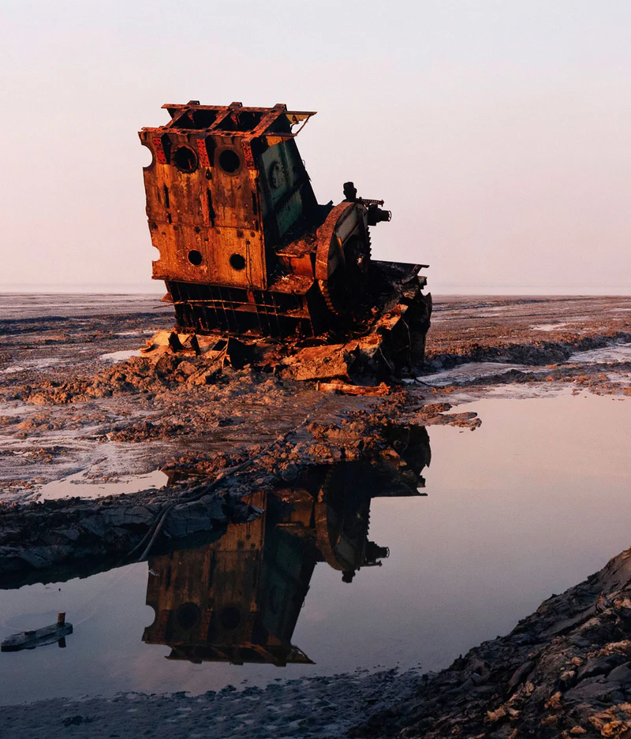

In this personal study I will be using two main artists to show environments in different locations in the world. This is so I can convey how human involvement is destroying the natural earth and ruining aesthetics for humans also. I will use two images one from each artist to highlight what is going wrong and how humans have created this problem. But to also use the images as a symbol to show this isn’t the only wrongdoing happening by human involvement as it happens all over the world and has been doing so for decades. A first artist I will use in the study is Edward Burtynsky. Who is a prominent and diverse photographer who expresses his work to portray how human influence and inventions. He does this by demonstrating human destruction of the environment by using a beautiful, terrible aesthetic to create large format high resolution photographs that depict the massive scale of human altered landscape such as mines, quarries, and waste disposal sites. Burtynsky often photographs from high vantage points using drones, helicopters and aircrafts. This aerial perspective abstracts the landscape, turning environmental damage into mesmerizing often painterly patterns of lines forms and colours. This initially draws the viewer in with a sense of awe and amazement only for them to realize the unsettling reality of the subject upon closer inspection and research .In this personal study I will be using Ed Burtynsky Bangladesh Shipwreck series to highlight how the images show natural environments and landscapes being used as a rubbish ground for human waste such as excess building materials, wasted structures and in this case unused ships. I will show how human involvement affects the environment through analysing what effects they have and how they directly ruin aesthetics to natural areas such as Bangladesh. By analysing the images, I can highlight what is involved and why it has happened which leads to ruining environments, therefore showing how the images chosen from Ed Burtynsky portray the need for human waste to not be left to destroy natural environments any longer.
A noted filmmaker, entrepreneur, and environmental advocate, Burtynsky is first known internationally for his large-scale images documenting the consequences and process of using the earth's natural resources. Perhaps his most striking and innovative series is the images from Shipbreaking. Burtynsky presents a group of works that had been impossible to imagine; what happens to ocean liners when they are out of commission? Where do they end up and how are they dismantled? Mostly taken in Bangladesh, these striking and moody photographs in a distinctive palette are intriguing, disturbing, and curiously beautiful.
Edward Burtynsky's work can be found in the permanent collection of countless museums including the National Gallery of Canada, the Guggenheim, Tate Modern, and MoMA to mention a few.
About the image:
The work is arranged into two sections which include a distant object with a blank background (singular colour), and a reflection of the object in a puddle or stretch of water in the lower half of the image. The colour scheme employed is a faint orange and brown for the object and pale blue with a pink tint for the backdrop of the image and in the water reflection. The object which is out of commission ship that has been eroded to a fraction of original size in a barren landscape has a vivid representation within the image as the dark fainted orange rustic colour contrasting to the horizon and backdrop which is blue and pink even being highlighted in the reflection in the water directly below the shipwreck. The image has reoccurring shapes from a direct reflection. The overall sight of the image can be negative due to a man-made large object ruining a vast peaceful landscape. Being highlighted as a giant pile of rubbish. However, it can also be viewed as historic and have a memorable look. The image consists of an old badly eroded ship that has lost its look of a ship completely, only being able to view as a shipwreck when viewed upon closely and identified as so. The image has an environmental and economic view as it is portraying a view that should reach governments that man made things should not be left and ruin aesthetics of peaceful landscapes, of which this shipwreck does. It also can be viewed as a memorial piece as what was once a ship filled with people and memories hundreds of feet above the sea floor is now rustic, dismantled and stranded in a desolate area dried up of all water and life. Never going to be used again. Within the image there is no distortion or abstraction and has a representationally intention Aswell as an aesthetically pleasing image with a stunning reflection highlighting its memorable look and current viewpoint through rough erosion and weathering that has destroyed the ship completely.
Edward Burtynsky used a large-format view camera, specifically a 4x5 or possibly an 8x10 film camera, for his Shipbreaking series in Bangladesh around 2000-2001, which includes Shipbreaking 36, Bangladesh. He used a large format camera to achieve the incredible detail necessary for his very large prints and used colour negative film for this work and would position himself at high vantage points to capture the sweeping views which can be viewed in the background of the shipwreck in the photo. In the photo there is very natural light captured by the camera with a contrasted main object to background colour. Burtynsky also used a space element to the image by setting a high enough vantage point that captures the size of the background and how far it spans even with the main part of the image being dominated by the object which is the shipwreck. The main part of the image is in focus including the reflection captured in the water stream, only the part of the background expanding further away from original snapshot point is blurred and out of focus. The angle of the image allows this to be captured as the background can be seen from the higher vantage point. The lines on the image are jagged as what is left of the shipwreck is rough and eroded. Because of the reflection in the water on the image the balance is even as the reflection is directly below.
The work of the image does affect the viewer as it may trigger emotional thoughts to a viewer due to the memorial look of the shipwreck conveying a sense of loneliness and isolation which is portrayed even more through its reflection in the water, as if making the memorial view of the shipwreck be made stronger. The image covers other emotions as the spot in which the wreck lies is seen as a peaceful barren landscape, which can be argued that the man-made metal object ruins the landscape. This feeling is a image that portrays many other images in one which are also made by pollution from mankind ruining natural landscapes, giving another sense of emotion through one image. This gives the image a dejected mood far from civilisation and any sense of hope. Linking again to a bigger picture that each time we as humans pollute the natural landscape, marks are left. Transforming natural peace into eerie and melancholy feeling to the surroundings which is what the shipwreck is doing from ed Burtynsky.
Ed Burtynsky created the image in Bangladesh in 2001, sourced from caviar 20 official photography website. Edward Burtynsky travelled to Bangladesh in 2001 to document the ship-breaking industry near Chittagong, as part of his larger exploration of human impact on the Earth's landscape and the "ultimate in recycling" of massive industrial object.

"Shipbreaking #36, Chittagong, Bangladesh, 2001"
Website - https://www.flaunt.com/post/edward-burtynsky-great-acceleration
Marking his first solo institutional exhibition in New York City in over 20 years, The Great Acceleration features more than 70 of Burtynsky’s most powerful images, several never-before-seen works, and ultra-high-resolution murals that all force the viewer to reckon with the profound impact of human activity on the planet.
Burtynsky, long regarded as one of the world’s most accomplished contemporary photographers, uses his lens as both witness and warning through transformative works that expose the fragile intersection between humans and the environment. His photographs of human industrial landscapes represent over 40 years of his dedication to documenting the manmade impact on the planet. Burtynsky credits early exposure to the General Motors plant and the passing ships in Welland Canal in his hometown as the source for his curiosity on the scale of human creation. He finds those very industries that humans have shaped society’s normalcy to rely on and creates a dialogue between good, modern living and the planet’s consequential suffering through visual art. His works are meant to reckon with the contradiction of the consumer’s materialistic dependence and their simultaneous concern for environmental wellbeing.
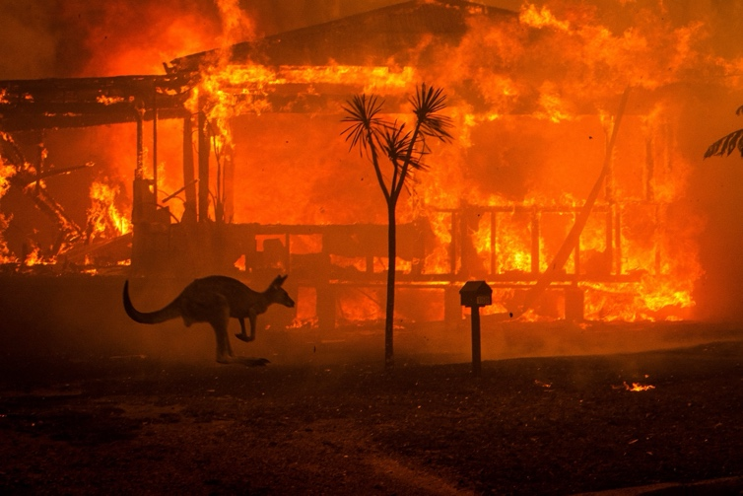

Matthew Abbott is an Australian freelance photojournalist and documentary photographer born in 1984.He was named "Photographer of the Year 2022"
Between June 2019 and May 2020, the bushfire season in Australia was so violent The final view of the images created by the artists have been done by different cameras and lenses. The making of the images allowed through the camera gives the artist not only purpose but eligibility to portray many different messages either using a symbolistic or direct centre point. In this study i have used ed Burtynsky and Matthew Abbotts images to highlight how they have both direct and symbolistic views upon how humans are changing natural landscapes both directly through dumping debris but second Handly through climate change which is seen on the Kangaroo running in the fire. The use of the camera allows for major awareness to be shown to its targeted or non-targeted viewers as they can easily see what is happening and what other things are happening just like the two images highlighted by both Ed Burtynsky and Matthew Abbott.
that 24.3million hectares were ravaged, more than 3,000 buildings destroyed, 88 billion Australian dollars in financial losses, 34 people killed, and 3 billion terrestrial vertebrates killed, it was one of the greatest disasters in the country’s recent history. Photographer Matthew Abbott captured the tragic event and won a World Press Photo award for his image of a kangaroo hopping past a burning house.
In this piece of photography by Matthew Abbott, there is an arrangement of a burning building located in Lake Conjola New South Wales Australia. The image depicts a soul of Australia’s wildlife running for survival in the events of a environmental tragedy. The image uses the impacts of only two colours in different shades, including orange and black. The image uses a contrast through the bright flames roaring in the background with the outline of the kangaroo and palm trees in full black as the only source of light is the flames. This makes the image be very vivid in the top third as the burning building has huge flames burning behind the kangaroo and palm tree. The predominant colour is the shades of orange because of this. With the flames being so bright, the objects and animal in the image are outlined making full forms, making the image be subject of detail from both direct flames and shadows caused by its brightness. The overall objective of this work is to highlight the dangers that wildfires cause to the habitants of both new south Wales and the whole of the outback of Australia. The actual image itself has been caused by the increase in temperature to climates making shrubbery drier and sunlight cause natural fires easier and in more powerful measures. The image has captured the power of the fires and how nature is paying the price, which we can see through the burnt trees and shrubs but also the kangaroos frantic running to escape the fire. The image is of direct observation and is treated representationally for the purpose of both environmental and wildlife awareness. This makes the image be immediately apparent to the viewer through exaggerating what is happening directly but also as a symbol because many situations like this happen frequently in these events that are not captured by camera.
The image was captured with a Nikon D5 Camera and was captured by Matthew Abbott being on the front line of an Australian wildfire burning through towns and villages. The image was carefully depicted as Matthew waited for the opportunity to catch the kangaroo to be in direct line with the fire to create such a clear outline. The artist would have had external help to receive safe and secure measures with detail to collect such images without being caught in the blaze crosswinds. The work will have had to be executed rapidly because of this making the artist to be very good with precision and motion blur and Lense technicality. The composition of the image is arranged into a bright background in a dark scenario causing outlines of a kangaroo and palm tree located in the lower section of the image. The image is therefore dominated by its background of bright flames and burnt building engulfed in the flames leading to a contrast of bright orange and pitch black. From these elements the image is therefore unbalanced from heavy textured and brighter in the top to full black on the lower third. Creating the rule of thirds within the image as the middle third is the outline of wildlife and palm trees centred in the image. The image will affect the viewer as it shows how much harm and destruction is caused to living things and environments all around Australia and other countries from the main factor climate change which is caused by human involvement. Creating a negative feeling of anguish and sadness upon first sight This image can be disturbing to viewers as it may expose the deaths of many wildlife animals even humans through wider knowledge. The qualities of such an image collect destructive and torment of which such fires create, causing a negative feel from the image in whole. Matthew Abbott was the artist to create this work in lake Conjola new south Wales Australia. This is sauced from the website located in the study. The purpose of the image is to highlight the destruction caused by wildfires which happen due to direct human involvement of climate change.
Matthew Abbott image website:
https://www.walkleys.com/award-winners/press-photographer-of-year-matthew-abbott/
Overall, I have chosen to do this study about the environment so I can easily show what is happening to the environment all around us which keeps on worsening. What is happening is that we are using natural peaceful landscapes like Bangladesh and dumping waste and unused materials there. Which we can see on Ship- Wrecked #36. The main aim of using this image is to use it as a symbol to what humans are doing wrong and show how much we are ruining environments with such large amounts of waste. The image itself shows how its rustic and large quantity not only ruins the land it Is lay on but pollutes things like the water way located next to it which can damage wildlife and plantation. The artist used to do this is Edward Burtynsky on his ‘Shipwrecked’ expedition from 2000-2001. The use of his photograph outcomes allows them to be viewed not just directly but as a symbol through the bigger picture showing that this happens on bigger and more frequent amounts across the natural earth.
Another artist I have used in the study is Matthew Abbott who states “things aren’t like they used to be” on factors about the environment. The work I have used of his is his famous “running kangaroo in the fire” which happened because of a wildfire in New South Wales Australia. I have used this image because not only does it show damage to nature and plantation like Edward Burtynsky, but it shows again how human involvement worsens the earth. This is because the wildfire shown in the image was caused by an increase in temperature of that area causing drier plantation and higher sun frequencies causing a wildfire, directly caused by climate change from decades of human pollution of the atmosphere. This enables me to highlight the image of Matthew Abbott like Ed Burtynsky “Shipwrecked” as it shows direct problems from human involvement on natural landscapes.
I have used the artist in the study on environments as they show how the use of cameras taking such images, reflecting the destruction of humans on the natural landscapes across the earth, can be used to be more powerful than words. This is because the images caught by such cameras can capture intense detail and variety in backgrounds seen in Ed Burtynskys work. Allowing the images to be used as a symbol of awareness for the human involvement day to day which is unseen by most of the world. Therefore, allowing the camera to express intense detail and external thoughts, making the camera and photography push a major message which goes a lot further then a message on an article. All from the specific moments and knowledge the artists go through to receive such images, seen in the precise moment Matthew Abbott captures the running Giraffe.

